Badminton Coaching Assistance System Using Deep Learning

User Manual

# Initiating the system

1. Follow the installation kit step to install the require tools.
2. Open the app.py file.
3. Open a browser (Google/Microsoft Edge), input “localhost:5000” to the URL section.
4. The login screen of the system will be shown.

# User Manual of the proposed system

**2.1 Login to the system**

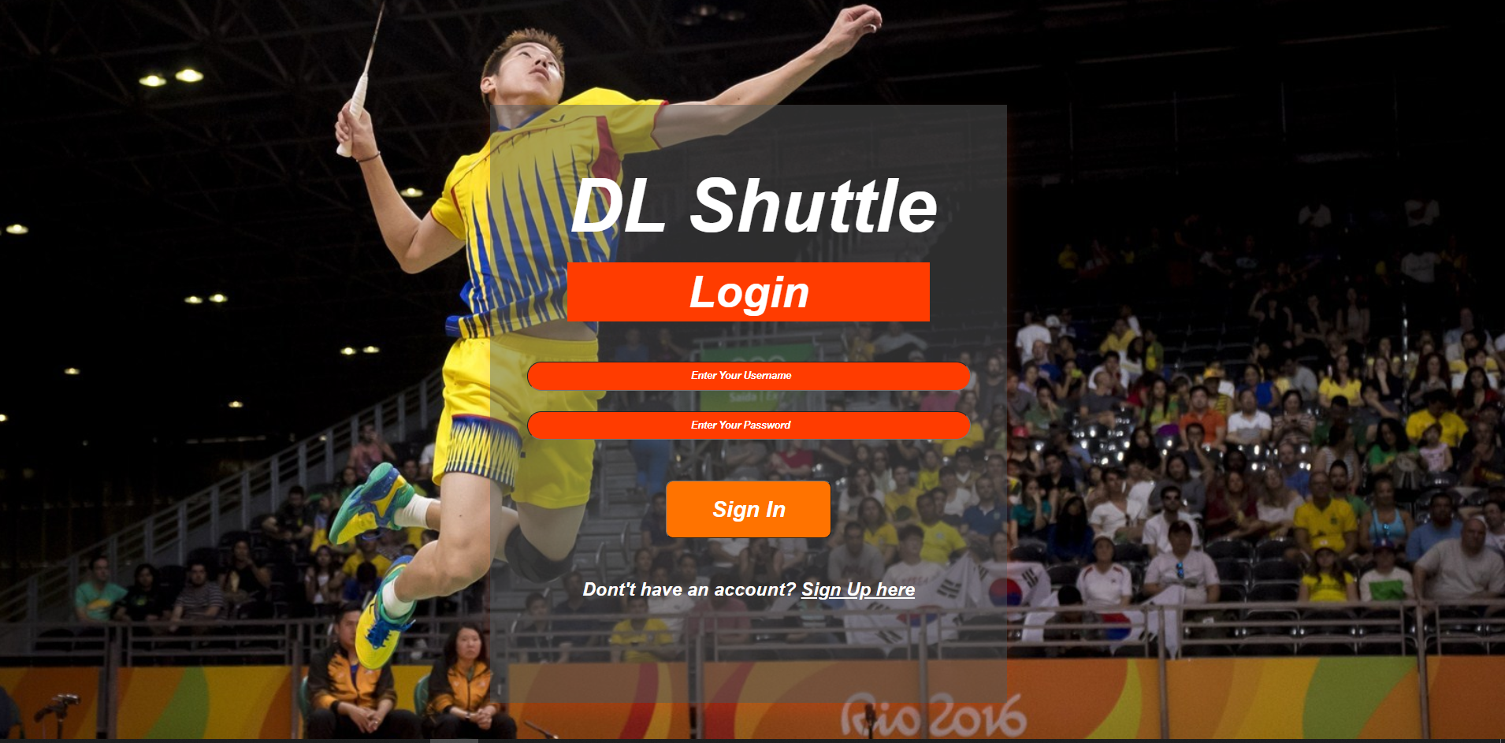

4

3

2

1

Figure 2.1: Login Page

|  |  |  |  |
| --- | --- | --- | --- |
| **No** | **Name** | **Description** | **Required** |
| 1 | Username | User’s username to login | Yes |
| 2 | Password | Password of the user’s account to login | Yes |
| 3 | Sign In Button | Button for user to submit their details for login verification | - |
| 4 | Sign Up Here Button | Button for new user to create a new account | - |

**2.2 Registration of New Account**

When user select Sign Up Here button, the system will navigate to this registration page.

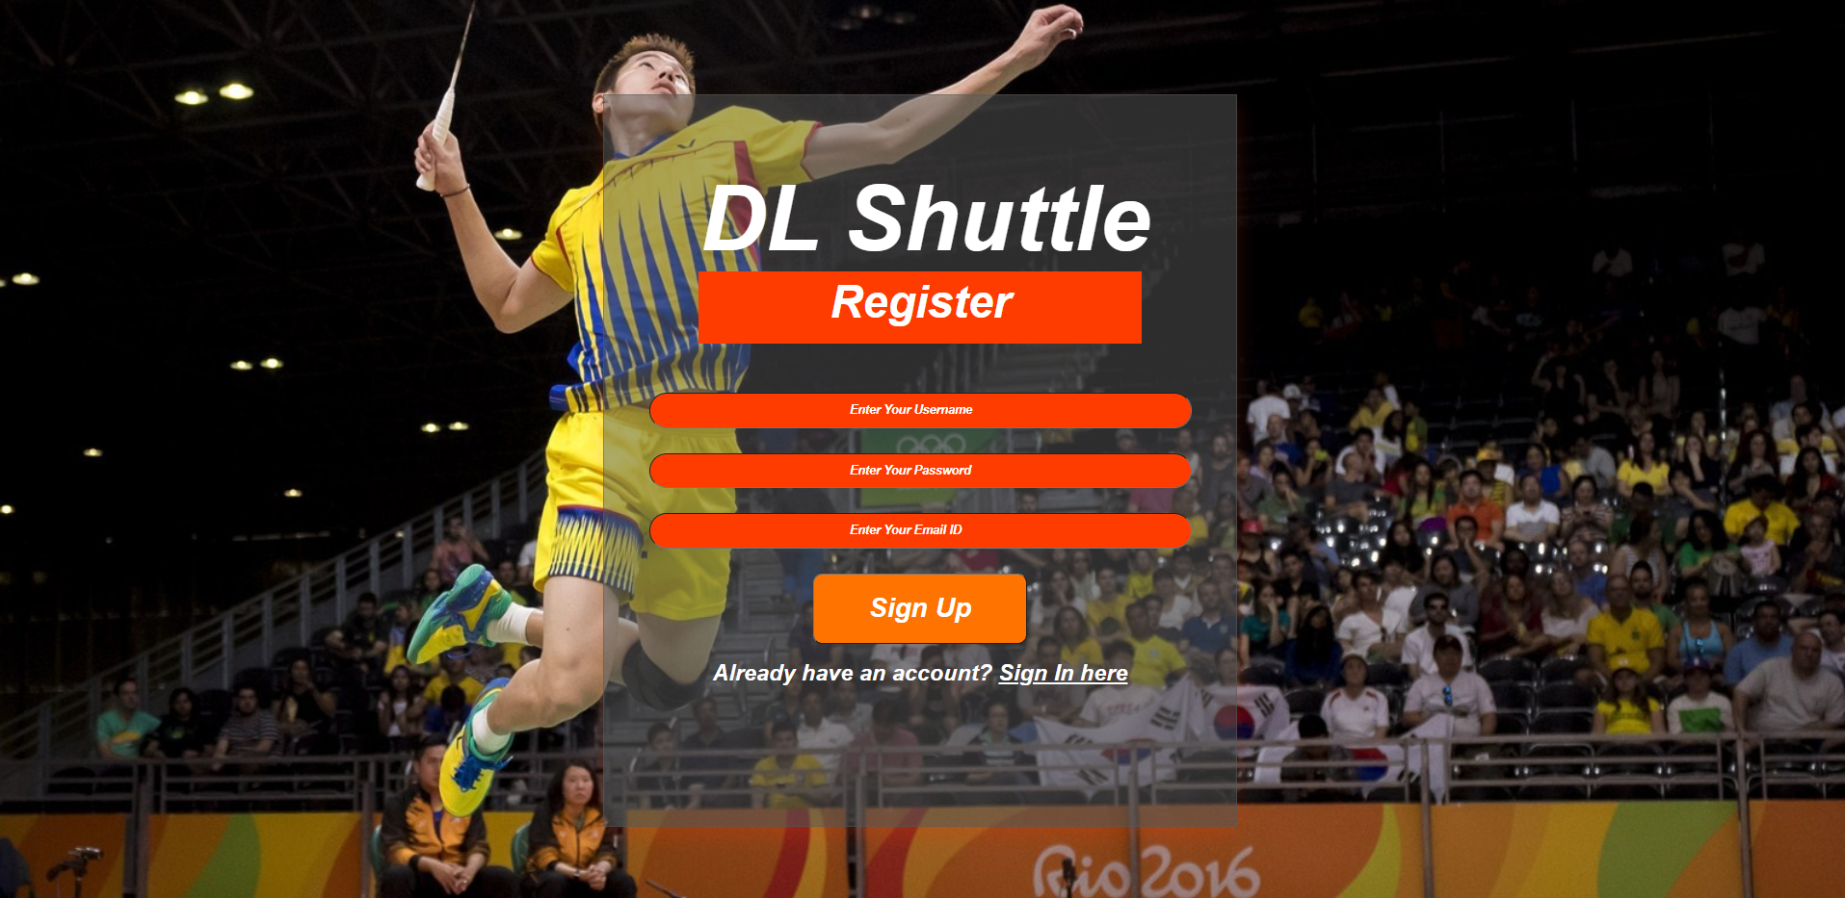

2

4

3

1

5

Figure 2.2: Registration Page

|  |  |  |  |
| --- | --- | --- | --- |
| **No** | **Name** | **Description** | **Required** |
| 1 | Username | Create a username for user’s account | Yes |
| 2 | Password | Create a password for user’s account. | Yes |
| 3 | Email ID | Provide user’s email for further notification, must be a valid email address to submit. | Yes |
| 4 | Sign Up Button | Button for user to submit their form to register a new account | - |
| 5 | Sign In Here Button | Button to return login page | - |

**2.3 Homepage**

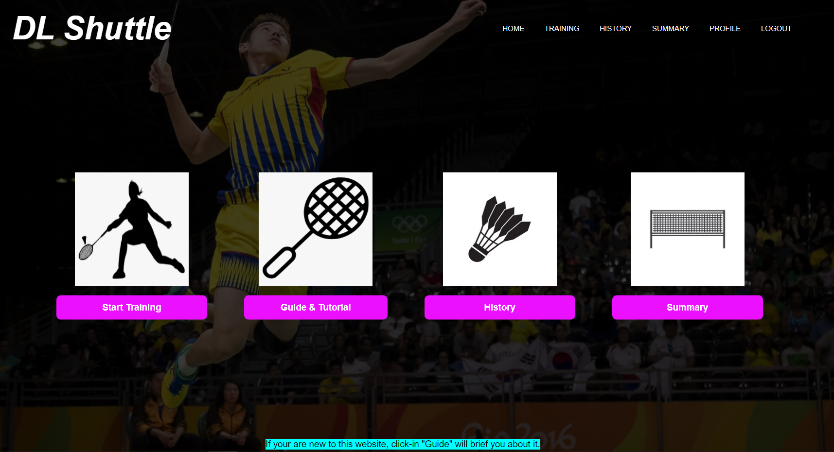

10

9

8

7

6

5

4

3

2

1

Figure 2.3: Homepage

|  |  |  |
| --- | --- | --- |
| **No** | **Name** | **Description** |
| 1 | Homepage Button | Button to navigate to homepage |
| 2 | Training Button | Button to navigate to skill selection page for training |
| 3 | History Button | Button to view history of training. |
| 4 | Summary Button | Button to view user’s training summary |
| 5 | Profile Button | Button to edit user profile |
| 6 | Logout Button | Button to Exit user account and back to login page |
| 7 | Start Training Button | Button to navigate to skill selection page for training |
| 8 | Guide & Tutorial Button | Navigate to page to guide user to use this system and some badminton skill tutorial. |
| 9 | History Button | Button to view history of training. |
| 10 | Summary Button | Button to view user’s training summary |

**2.4 Skill Selection Page**

When you select Start Training button, the system will navigate to this skill selection page for user to select a skill for training.

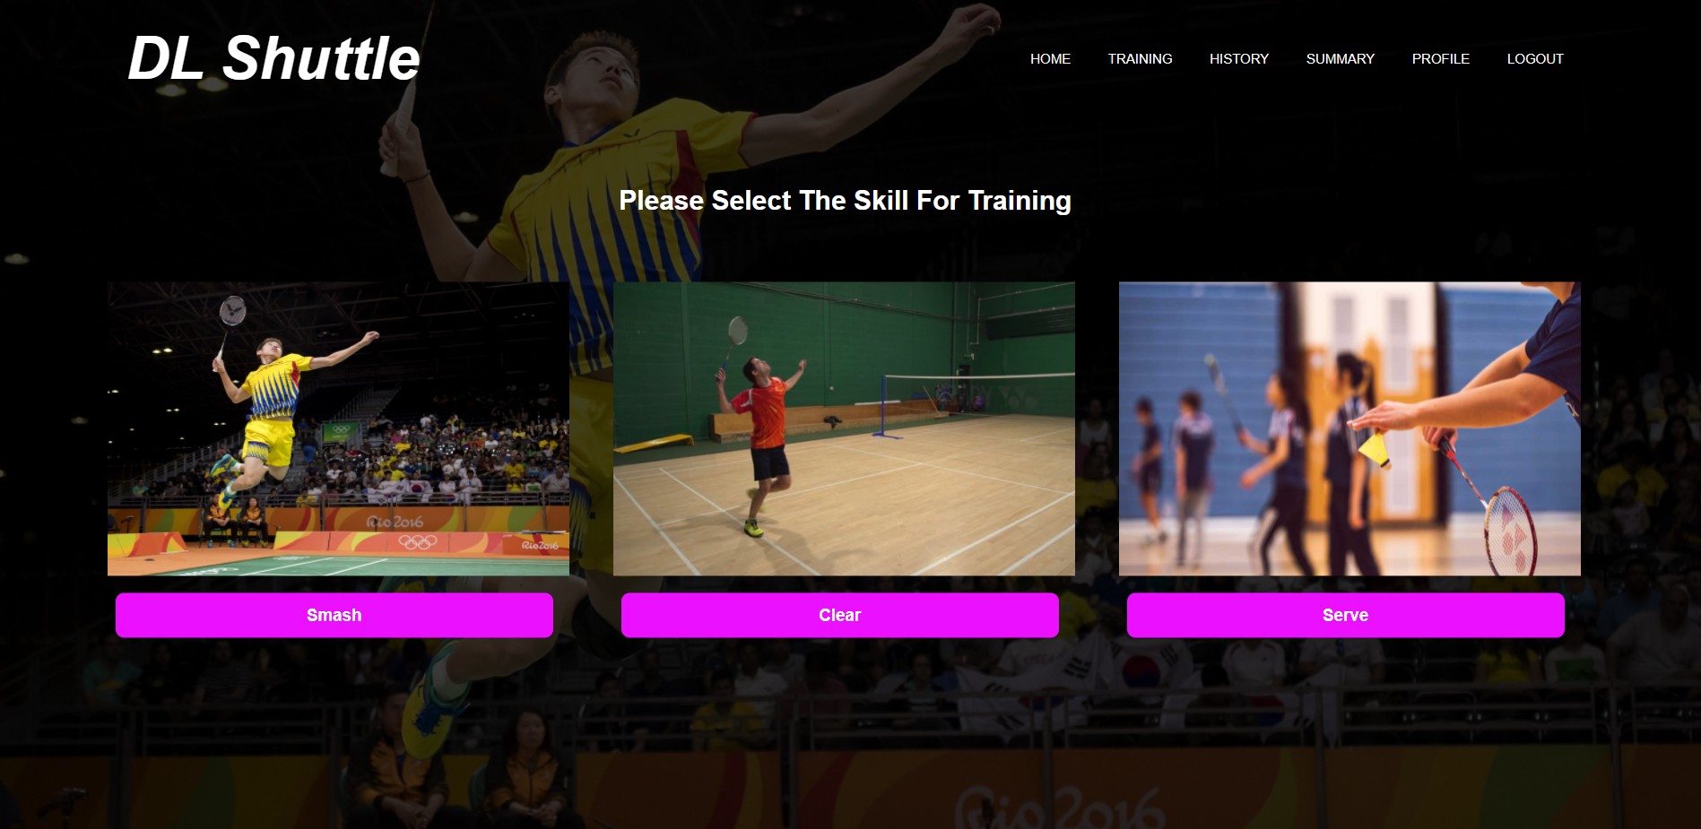

7

8

9

6

3

4

5

2

1

Figure 2.3: Skill Selection Page

|  |  |  |
| --- | --- | --- |
| **No** | **Name** | **Description** |
| 1 | Homepage Button | Button to navigate to homepage |
| 2 | Training Button | Button to navigate to skill selection page for training |
| 3 | History Button | Button to view history of training. |
| 4 | Summary Button | Button to view user’s training summary |
| 5 | Profile Button | Button to edit user profile |
| 6 | Logout Button | Button to Exit user account and back to login page |
| 7 | Serve Button | Select to train serve technique. |
| 8 | Clear Button | Select to train clear shot technique |
| 9 | Smash Button | Select to train for smash technique |

**2.5 Upload Video File Page**

After you selected a skill, you will navigate to this page for your to upload your training video for training. Select “Choose File” to find your video in your directory and click “Upload Video” to upload it to the system. Then, select “Start Video Training” to start the video processing.

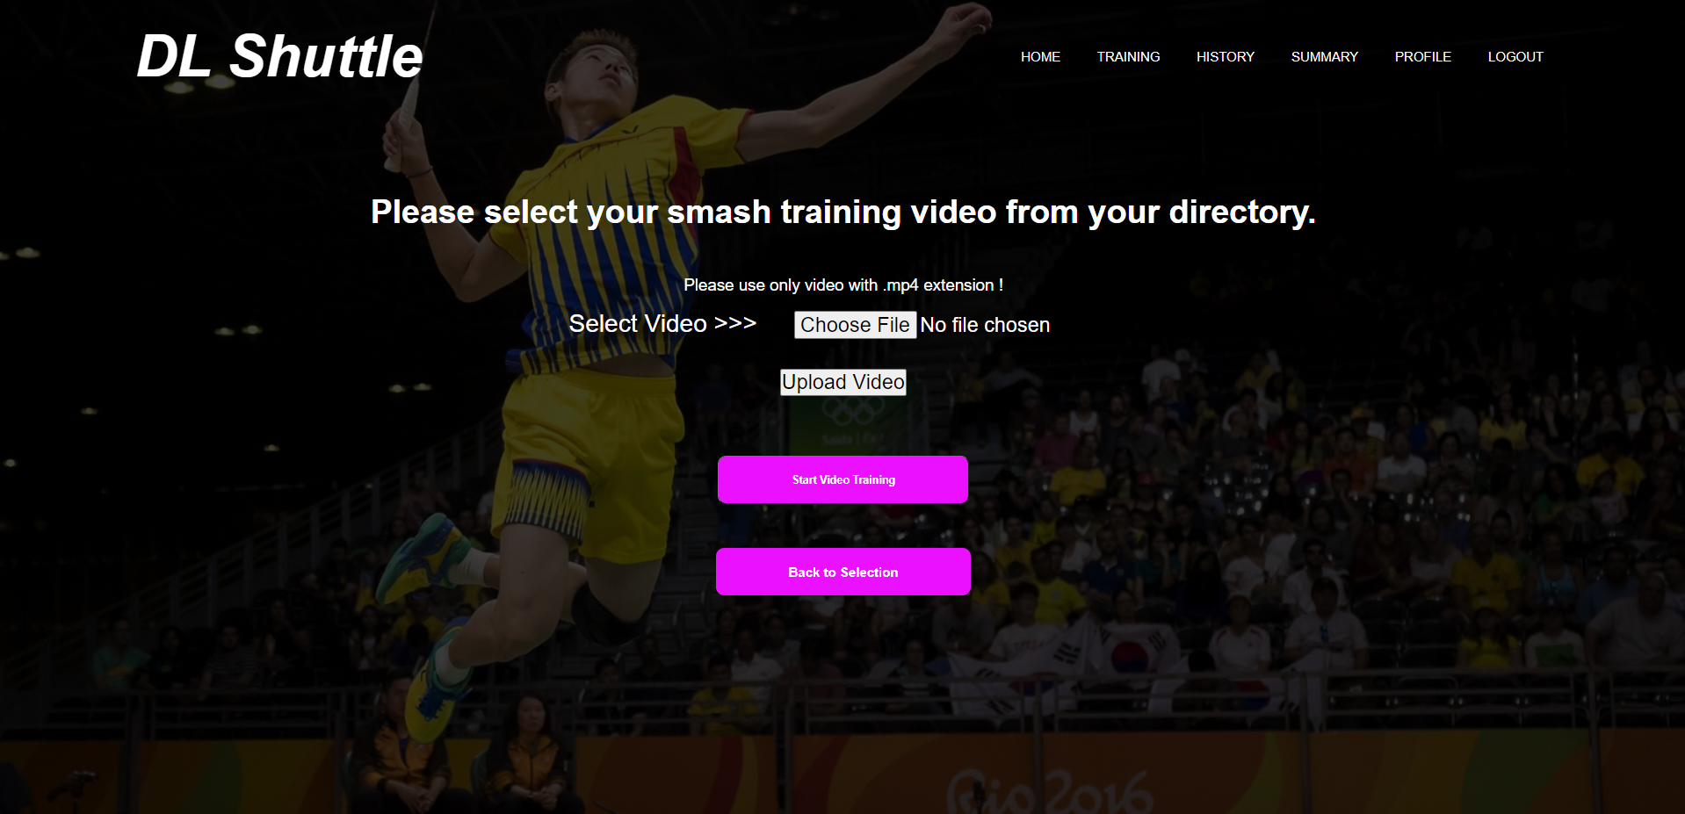

10

9

8

7

6

3

4

5

2

1

Figure 2.3: Upload Video File Page

|  |  |  |
| --- | --- | --- |
| **No** | **Name** | **Description** |
| 1 | Homepage Button | Button to navigate to homepage |
| 2 | Training Button | Button to navigate to skill selection page for training |
| 3 | History Button | Button to view history of training. |
| 4 | Summary Button | Button to view user’s training summary |
| 5 | Profile Button | Button to edit user profile |
| 6 | Logout Button | Button to Exit user account and back to login page |
| 7 | Choose File Button | Select the training video file from your directory. It must be a .mp4 file. |
| 8 | Upload Button | Upload the video file to the system to process |
| 9 | Start Video Training Button | Button to start the video processing for the upload file. Will take up some time depends on the video length. |
| 10 | Back to Selection Button | Return to skill selection page. |

**2.6 View Training Results Page**

When the video finish processing, this page will be generate and user can view their training results on the number of correct pose, incorrect pose, total, percentage of correct pose, percentage of incorrect pose, and a comment for players to improve their skill.

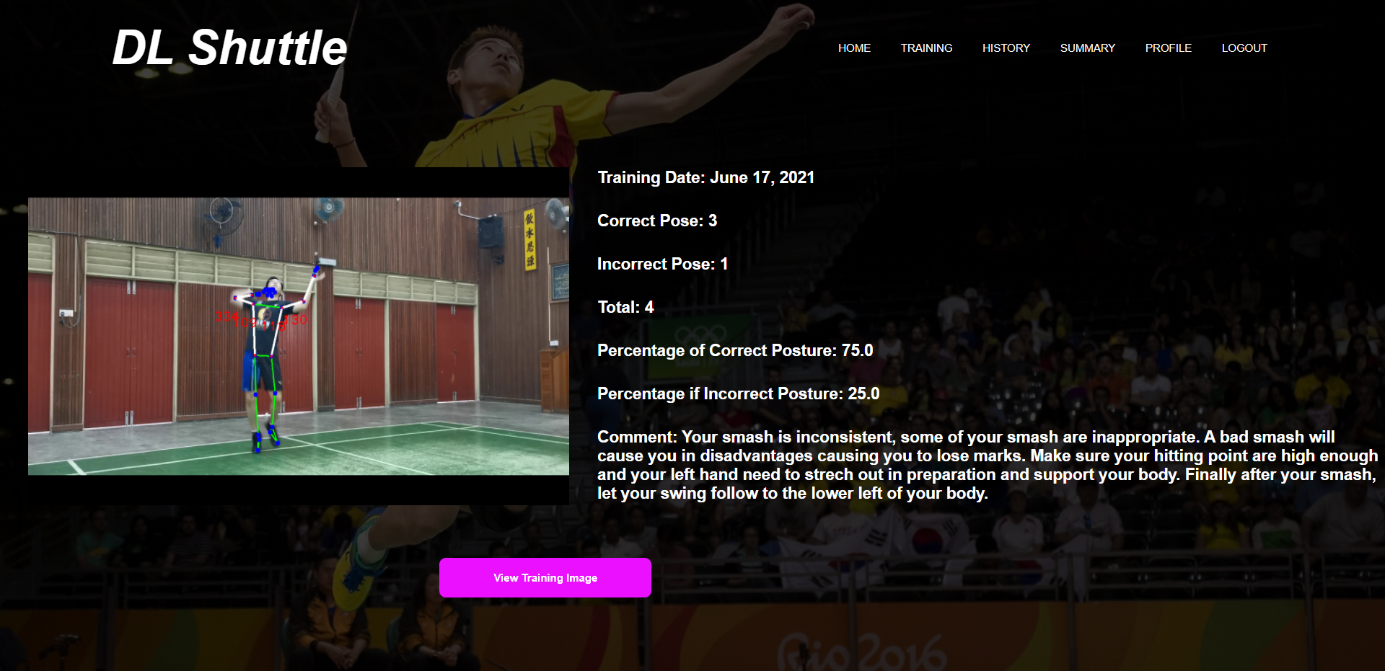

7

6

3

4

5

2

1

Figure 2.3: View Training Results Page

|  |  |  |
| --- | --- | --- |
| **No** | **Name** | **Description** |
| 1 | Homepage Button | Button to navigate to homepage |
| 2 | Training Button | Button to navigate to skill selection page for training |
| 3 | History Button | Button to view history of training. |
| 4 | Summary Button | Button to view user’s training summary |
| 5 | Profile Button | Button to edit user profile |
| 6 | Logout Button | Button to Exit user account and back to login page |
| 7 | View Training Image Button | Button to view the training image of correct and incorrect pose |

**2.7 View Training Image Page**

After viewing training results, user will navigate here to see their training image of correct pose and incorrect pose.

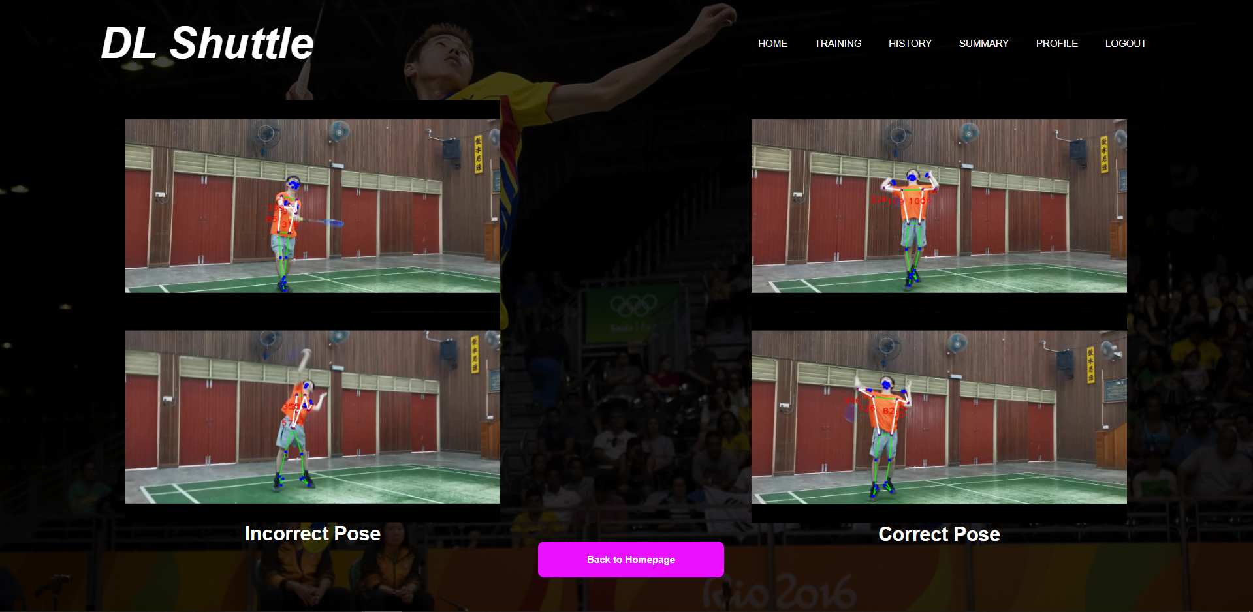

7

6

3

4

5

2

1

Figure 2.3: View Training Image Page

|  |  |  |
| --- | --- | --- |
| **No** | **Name** | **Description** |
| 1 | Homepage Button | Button to navigate to homepage |
| 2 | Training Button | Button to navigate to skill selection page for training |
| 3 | History Button | Button to view history of training. |
| 4 | Summary Button | Button to view user’s training summary |
| 5 | Profile Button | Button to edit user profile |
| 6 | Logout Button | Button to Exit user account and back to login page |
| 7 | Back to Hompage Button | Button to return to Homepage. |

**2.8 Introduction of the system**

When user click to guide and tutorial page, they will be navigate to this page to get to know about the system. On top of that, as user select next button some guide to use the system will be show.

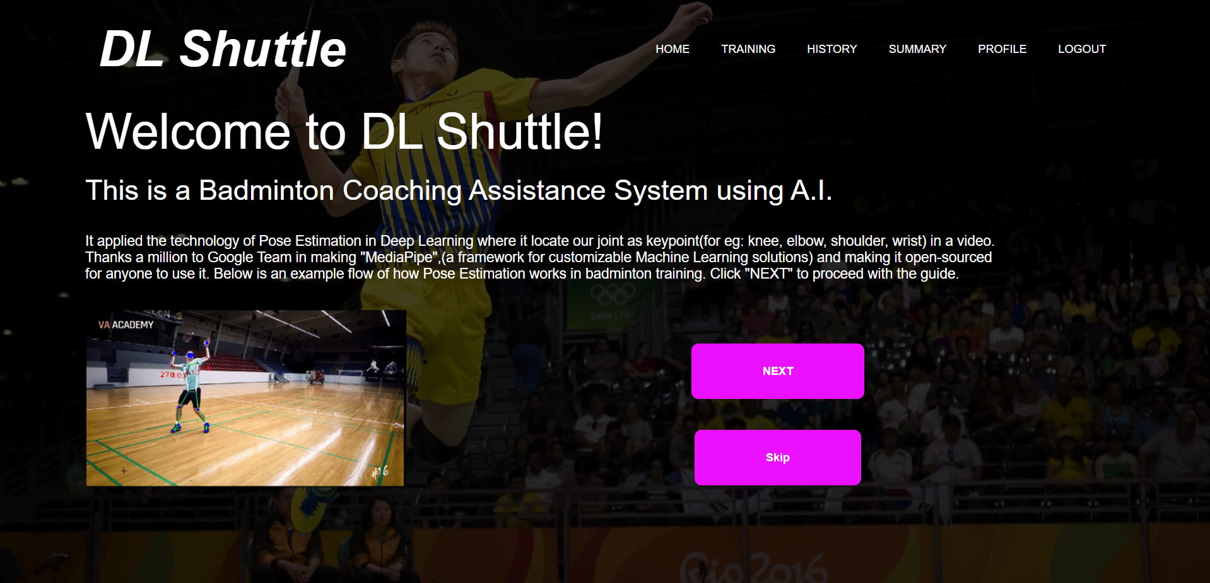

8

7

6

5

4

3

1

2

Figure 2.3: Introduction Page

|  |  |  |
| --- | --- | --- |
| **No** | **Name** | **Description** |
| 1 | Homepage Button | Button to navigate to homepage |
| 2 | Training Button | Button to navigate to skill selection page for training |
| 3 | History Button | Button to view history of training. |
| 4 | Summary Button | Button to view user’s training summary |
| 5 | Profile Button | Button to edit user profile |
| 6 | Logout Button | Button to Exit user account and back to login page |
| 7 | Next Button | Button to next guide page. |
| 8 | Skip Button | User can skip the guide page to the badminton tutorial page. This is for old user that had use this system before. |

**2.9 Guide to Record Video**

This page is a guide provided for user to know how to record the video for the system to process. User will navigate to this page after going through the introduction of the system.

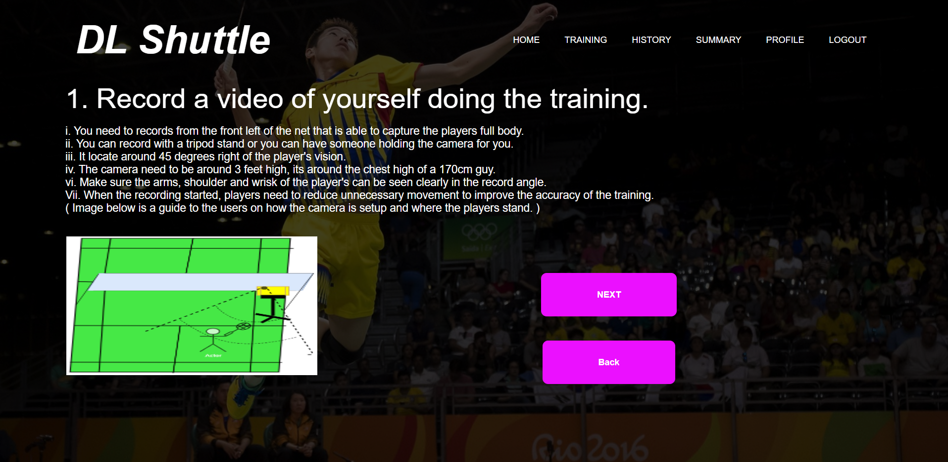

8

7

6

5

4

3

1

2

Figure 2.3: Recording Guide Page

|  |  |  |
| --- | --- | --- |
| **No** | **Name** | **Description** |
| 1 | Homepage Button | Button to navigate to homepage |
| 2 | Training Button | Button to navigate to skill selection page for training |
| 3 | History Button | Button to view history of training |
| 4 | Summary Button | Button to view user’s training summary |
| 5 | Profile Button | Button to edit user profile |
| 6 | Logout Button | Button to Exit user account and back to login page |
| 7 | Next Button | Button to next guide page, user will navigate guide to upload video page. |
| 8 | Back Button | Button for user to return to previous introduction page |

**2.10 Guide to Upload Video**

This page is a guide provided for user to upload their training video to the system.

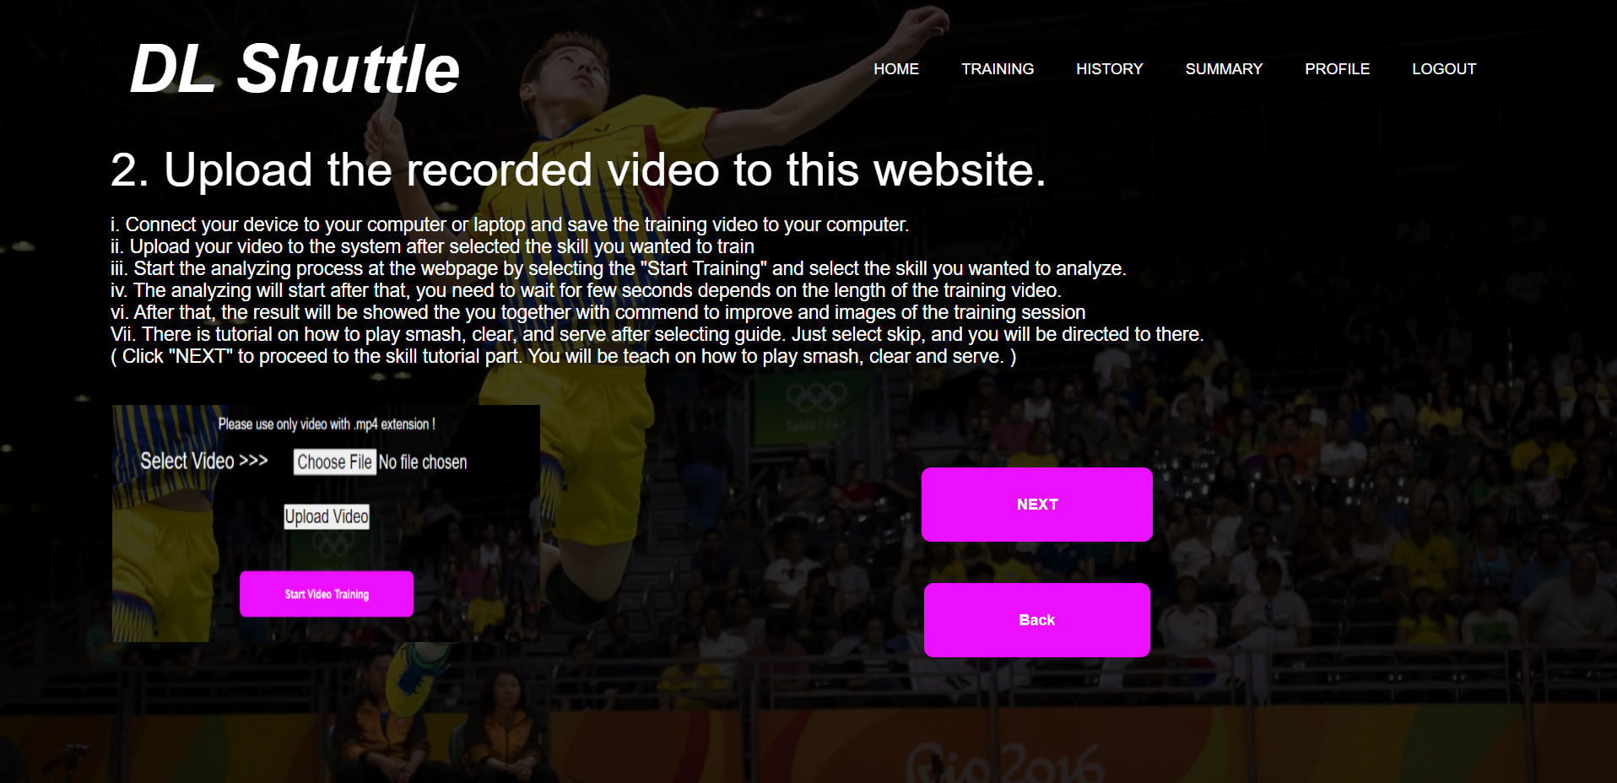

8

7

6

5

4

3

1

2

Figure 2.3: Uploading Guide Page

|  |  |  |
| --- | --- | --- |
| **No** | **Name** | **Description** |
| 1 | Homepage Button | Button to navigate to homepage |
| 2 | Training Button | Button to navigate to skill selection page for training |
| 3 | History Button | Button to view history of training |
| 4 | Summary Button | Button to view user’s training summary |
| 5 | Profile Button | Button to edit user profile |
| 6 | Logout Button | Button to Exit user account and back to login page |
| 7 | Next Button | Button to navigate to tutorial of badminton page to learn the basic of some badminton technique |
| 8 | Back Button | Button for user to return to previous Recording Guide Page |

**2.11 Tutorial Skill Selection Page**

This page let user to select a skill for tutorial and lesson of some basic of that technique.

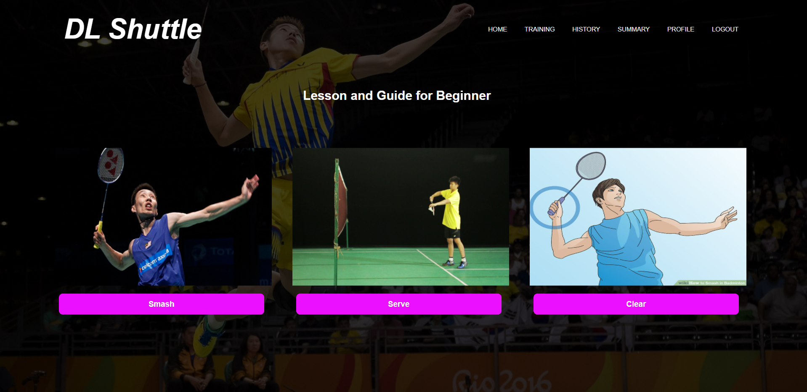

9

7

8

1

2

3

4

5

6

Figure 2.3: Skill Selection for Tutorial Page

|  |  |  |
| --- | --- | --- |
| **No** | **Name** | **Description** |
| 1 | Homepage Button | Button to navigate to homepage |
| 2 | Training Button | Button to navigate to skill selection page for training |
| 3 | History Button | Button to view history of training |
| 4 | Summary Button | Button to view user’s training summary |
| 5 | Profile Button | Button to edit user profile |
| 6 | Logout Button | Button to Exit user account and back to login page |
| 7 | Serve Button | Select to view tutorial for serve technique. |
| 8 | Clear Button | Select to view tutorial of playing clear shot technique |
| 9 | Smash Button | Select to view tutorial for smash technique |

**2.12 Example of Tutorial Page**

A example of the tutorial page of serving skill.

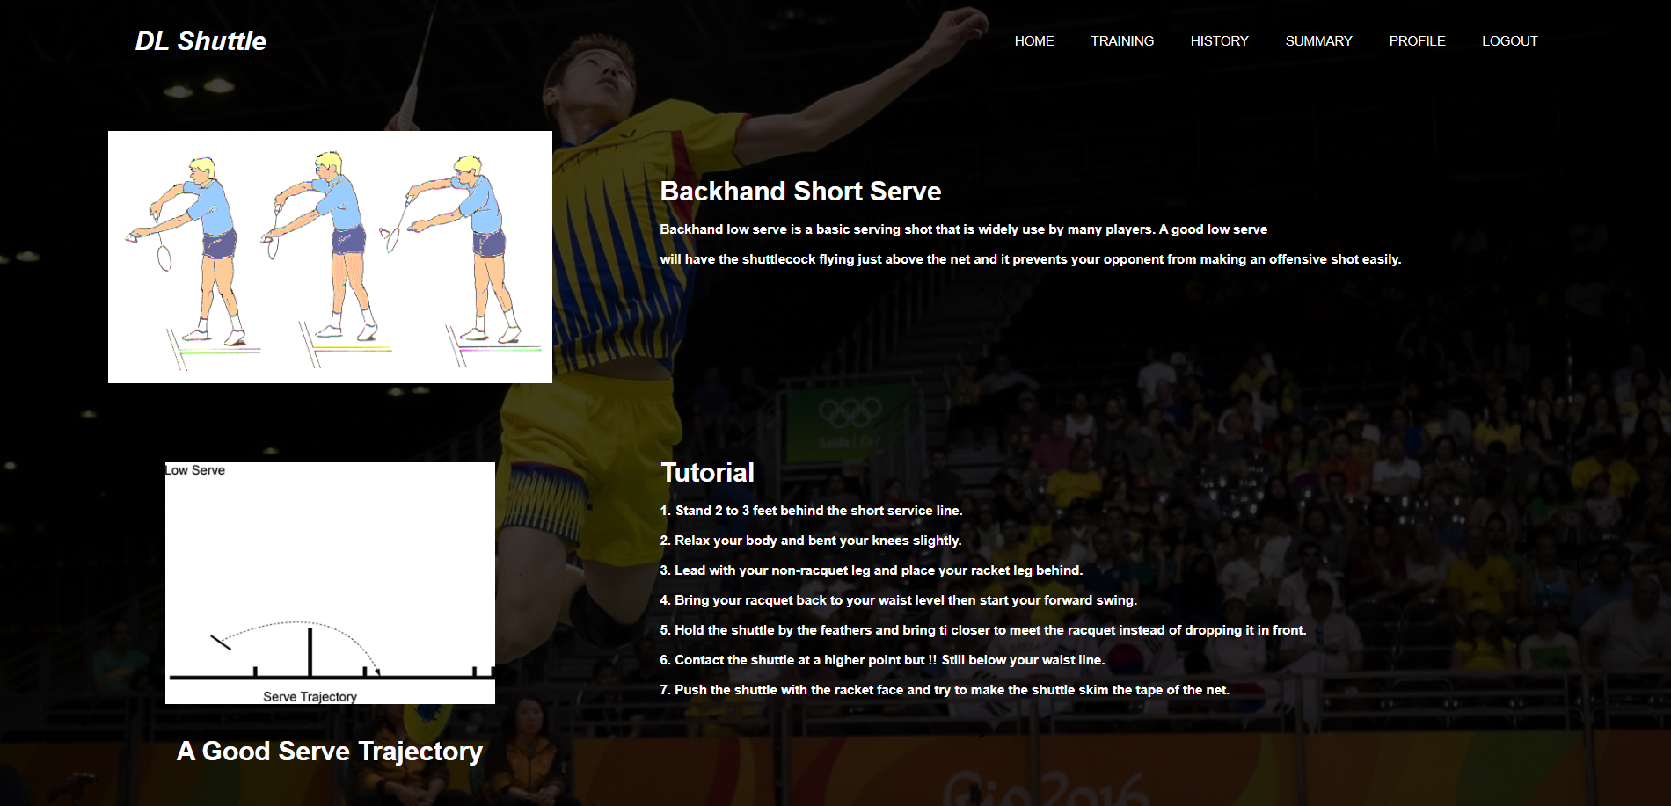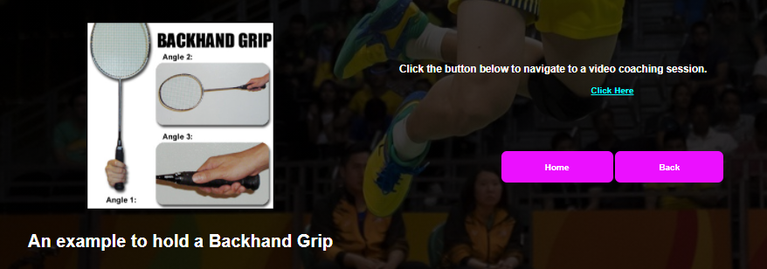

7

9

8

5

6

4

3

2

1

7

Figure 2.3: Example of Tutorial Page

|  |  |  |
| --- | --- | --- |
| **No** | **Name** | **Description** |
| 1 | Homepage Button | Button to navigate to homepage |
| 2 | Training Button | Button to navigate to skill selection page for training |
| 3 | History Button | Button to view history of training |
| 4 | Summary Button | Button to view user’s training summary |
| 5 | Profile Button | Button to edit user profile |
| 6 | Logout Button | Button to Exit user account and back to login page |
| 7 | Click Here Button | Link to a video tutorial of the basic of the badminton skill |
| 8 | Home Button | Button to return to Homepage. |
| 9 | Back Button | Back to selection of tutorial for other technique |

**2.13 View Training History Page**

This page will show all the training record that user done previously.

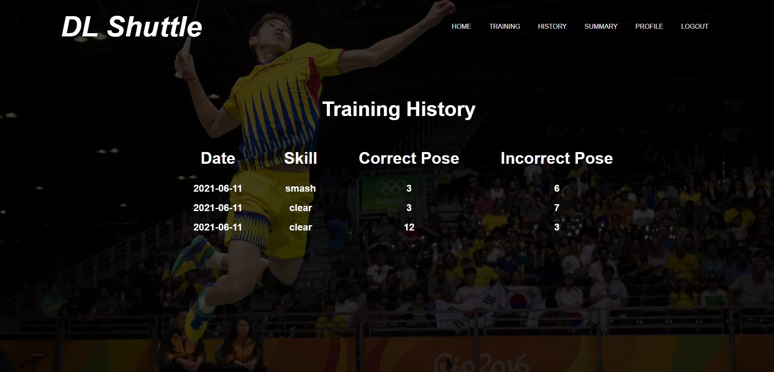

5

6

4

3

2

1

Figure 2.3: View Training History Page

|  |  |  |
| --- | --- | --- |
| **No** | **Name** | **Description** |
| 1 | Homepage Button | Button to navigate to homepage |
| 2 | Training Button | Button to navigate to skill selection page for training |
| 3 | History Button | Button to view history of training |
| 4 | Summary Button | Button to view user’s training summary |
| 5 | Profile Button | Button to edit user profile |
| 6 | Logout Button | Button to Exit user account and back to login page |

**2.14 View Summary Page**

This page will show the summary of training of user.

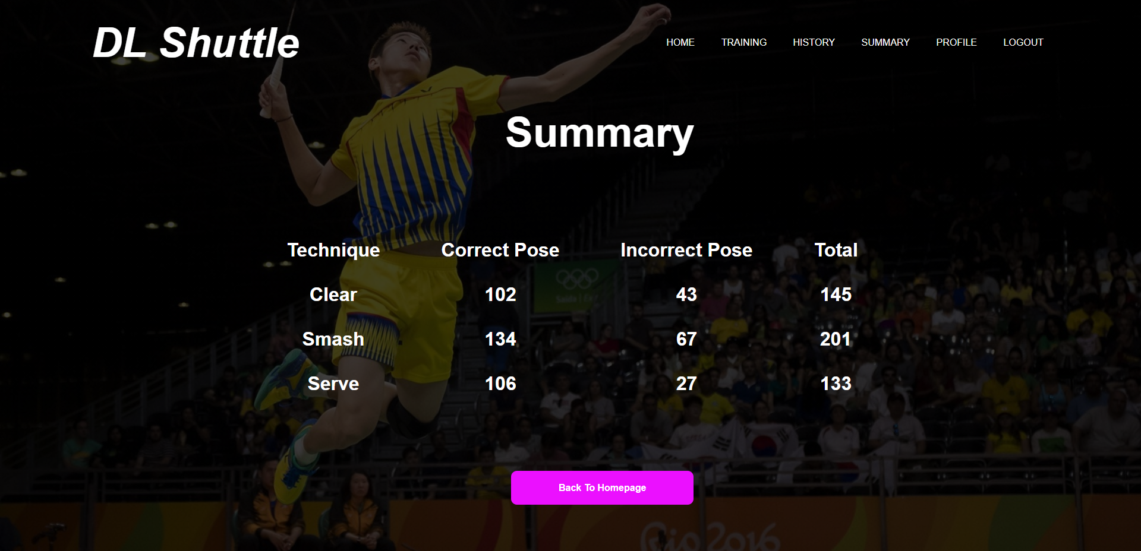

7

5

6

4

3

2

1

Figure 2.3: View Summary Page

|  |  |  |
| --- | --- | --- |
| **No** | **Name** | **Description** |
| 1 | Homepage Button | Button to navigate to homepage |
| 2 | Training Button | Button to navigate to skill selection page for training |
| 3 | History Button | Button to view history of training |
| 4 | Summary Button | Button to view user’s training summary |
| 5 | Profile Button | Button to edit user profile |
| 6 | Logout Button | Button to Exit user account and back to login page |
| 7 | Back To Homepage Button | Return to Homepage |

**2.15 Edit User Detail Page**

This page will show the summary of training of user, navigate from selecting profile from the tools bar above.

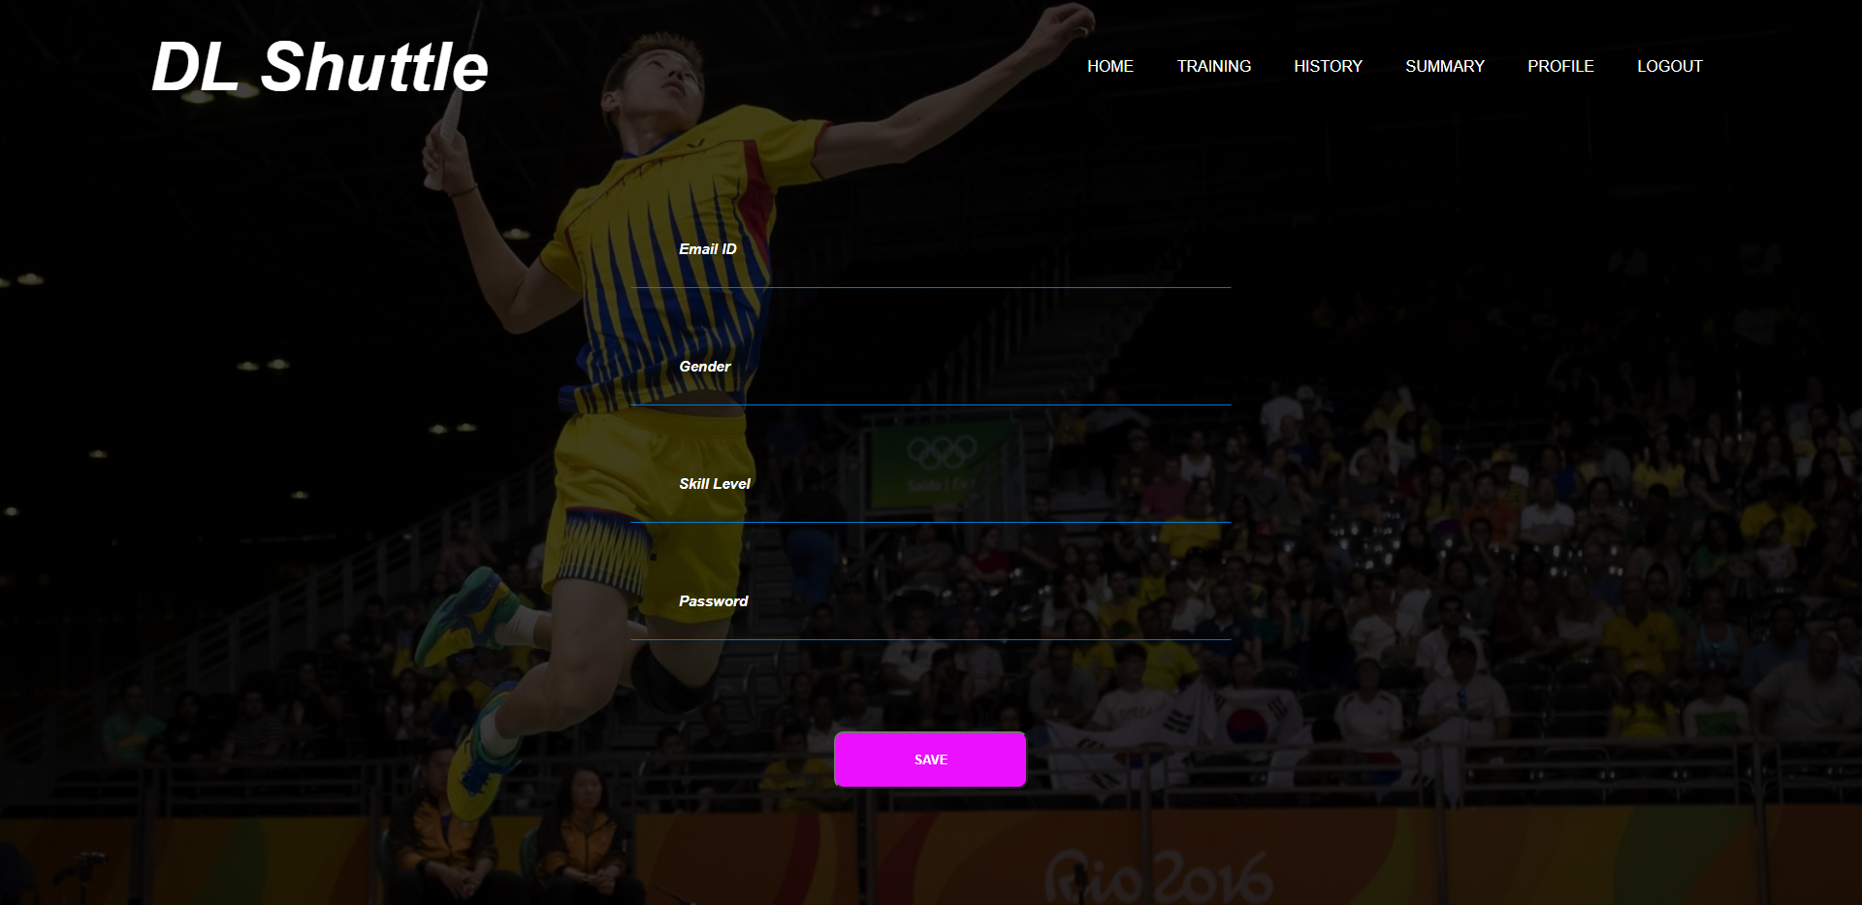

11

10

9

8

7

5

6

4

3

2

1

Figure 2.3: Edit user profile Page

|  |  |  |  |
| --- | --- | --- | --- |
| **No** | **Name** | **Description** | **Required** |
| 1 | Homepage Button | Button to navigate to homepage | - |
| 2 | Training Button | Button to navigate to skill selection page for training | - |
| 3 | History Button | Button to view history of training | - |
| 4 | Summary Button | Button to view user’s training summary | - |
| 5 | Profile Button | Button to edit user profile | - |
| 6 | Logout Button | Button to Exit user account and back to login page | - |
| 7 | Email Id | Update user email id here, only allow a valid email | Yes |
| 8 | Gender | Update user gender to the system, only allow alphabet | Yes |
| 9 | Skill Level | Update user skill level to the system | Yes |
| 10 | Password | Update new password of users to the system | Yes |
| 11 | Save | Update user details to the system, and store in database | - |